Results

This study looked at how Western Spruce Budworms affected nutrient contents in Central Washington coniferous forest throughfall as well as soil nutrient concentrations. Soil organic matter and moisture content were also investigated as well as the decomposition rate of coniferous needles.

Areas with greater budworm activity tended to have increased phosphorous in both throughfall and soils. Budworms also showed an increase in throughfall NH4+ concentrations, but not in soils. The percent organic matter in soils tended to be higher in low activity sites, but moisture was not impacted by budworm activity. Soil NO3- and total inorganic N were not affected by budworms, but the N:P ratio was greater in low budowrm sites.

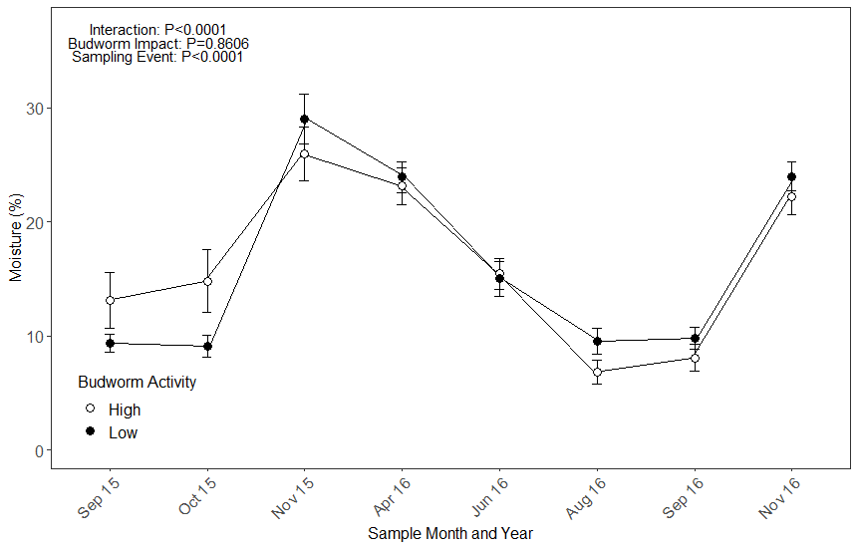

Figure 1: Moisture content in soils changes with seasonality. Months with more rain tended to increase moisture content in soils, but budworms had minimal effects.

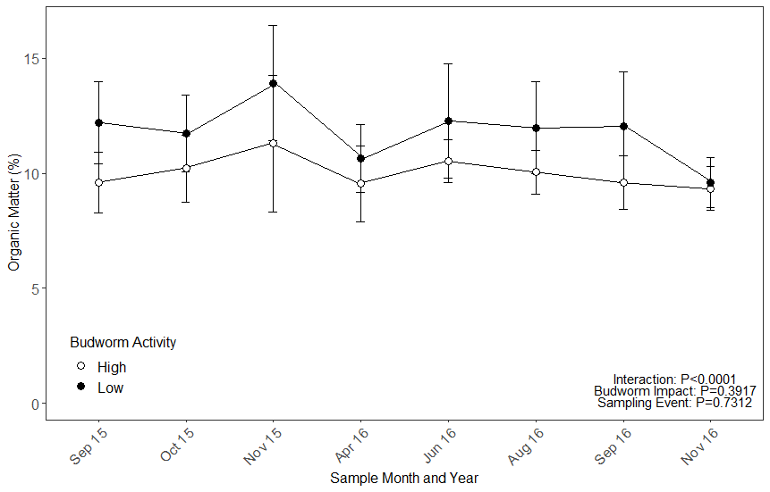

Figure 2: Organic matter tended to be higher in sites with low budworm activity but not significantly.

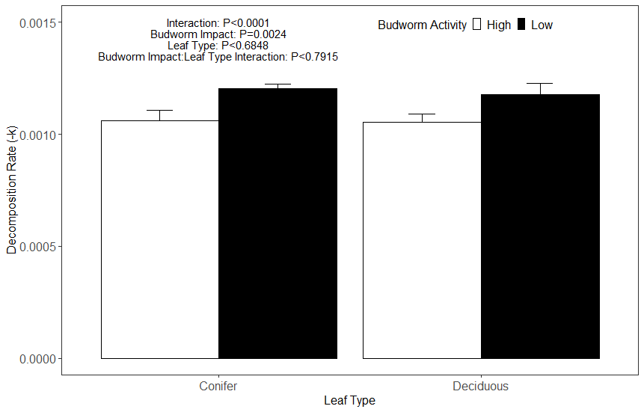

Figure 3: Litter decomposition rates were lower in areas with higher budworm activity. These rates were calculated from bags collected starting from September 2015 through November 2016.

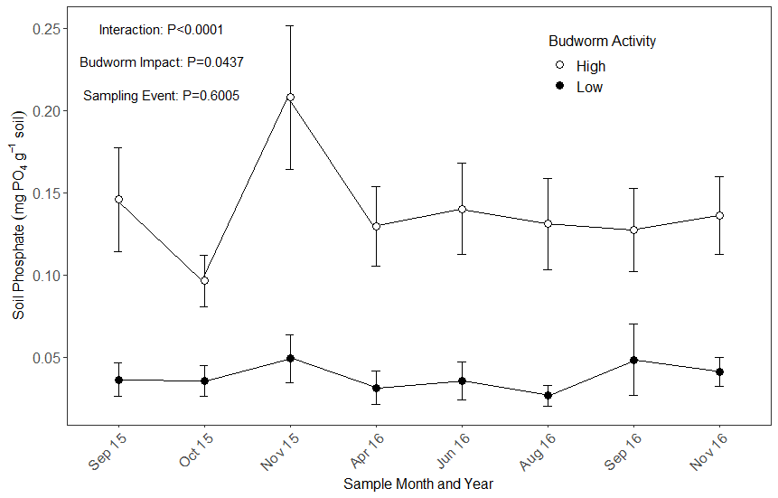

Figure 4: Soil phosphorous was significantly greater in sites with high budworm activity. This supports throughfall data.

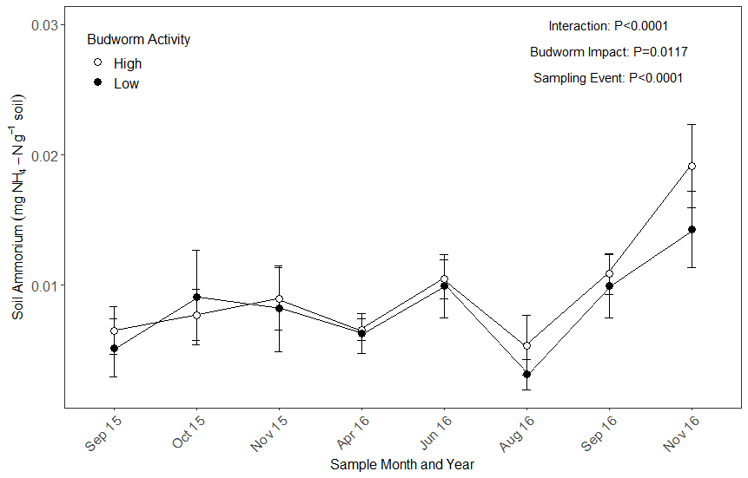

*Figure 5: Soil Ammonium was significantly greater in sites with high budworm activity.*

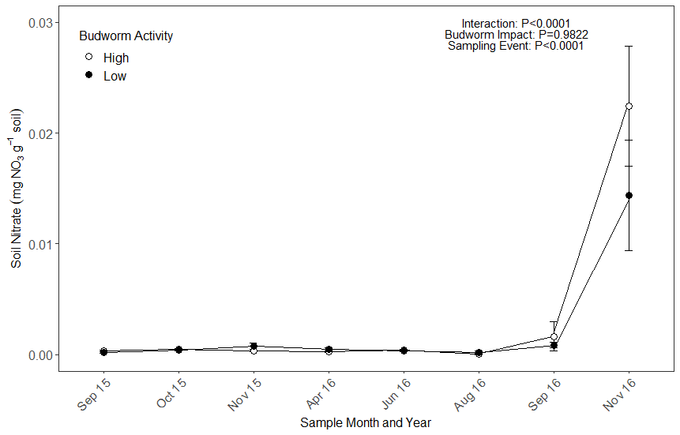

*Figure 6: Budworm impact did not affect soil nitrate concentrations, but concentrations during sampling events did significantly differed.*

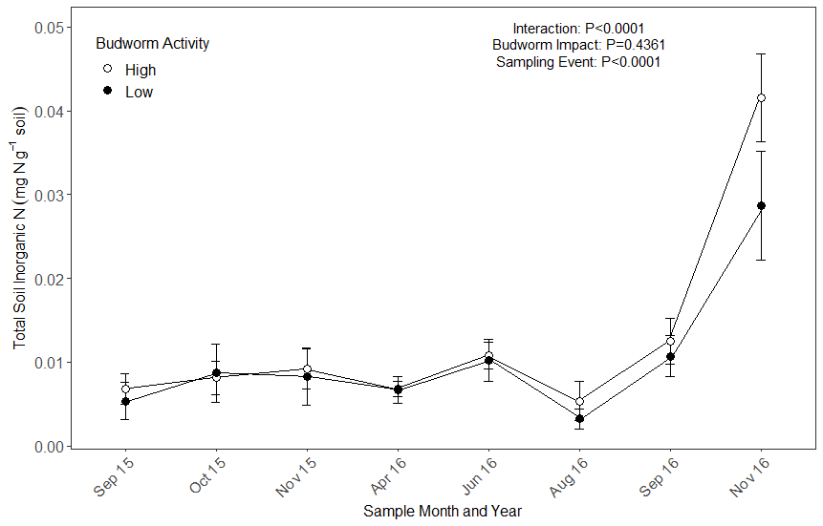

*Figure 7: Budworm impact did not affect total soil inorganic N concentrations, but concentrations during sampling events did significantly differed.*

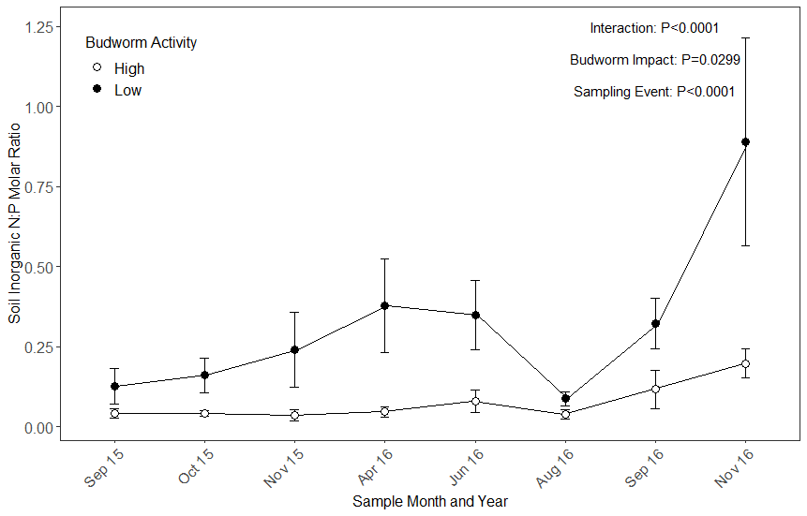

*Figure 8: Both budworm impact and sampling event had significant differences over the course of the study.*

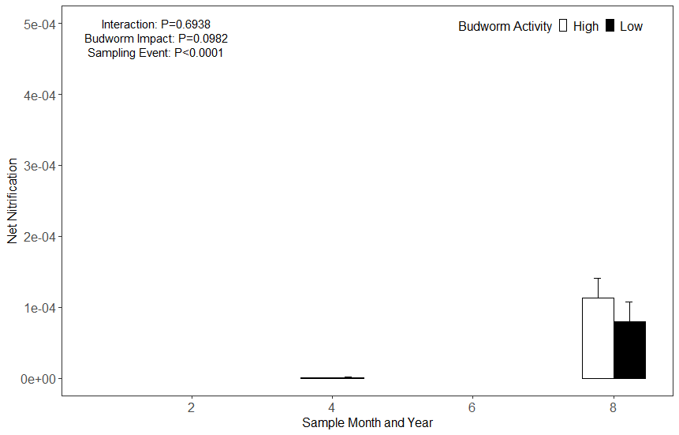

*Figure 9: Nitrification pre snow pack was significantly lower than post snow melt.*